“Dissemination of Education for Propagation of Knowledge,Achivement and Culture”

**-Shikshanmaharishi Dr.Bapuji Salunkhe.**

**Shri Swami Vivekanand Shikshan Sanstha's**

Vivekanand College ,Kolhapur

A Project Report on

**“Online Watch Shopping”**



Submitted By

**Miss.Sheetal Mahadev Dhokare.**

**Miss. Sarswati Mahadev Dhokare.**

Class : B.Sc.III

**Under The Guidance**

Miss.R.Y.Patil Madam

Submitted to

**Shivaji University,Kolhapur.**

For The Year 2018-2019

**ACKNOWLEDGMENT**

We have great pleasure to express our deep gratitude to Miss.R.Y.Patil Madam and Mrs Mujawar Sir for the valuable guidance and useful suggestion throughout the project.

All guides have always a source of inspiration for us. It is grateful guidance and constant encouragement which held successful completion of project.

In the last but not least we thank all our faculties, entire computer department and all others who have directly or indirectly helped us in completion of this project.

Miss. Sheetal Mahadev Dhokare

Miss. Sarswati Mahadev Dhokare

**DECLARATION**

To

The Principal,

Vivekanand College,

Kolhapur.

We undersigned declare that the project Report on “Online Watch shopping” is developed. This project work is based on the information collected by us.

We understand that any such copying is liable to be punished in a way the college authorities deem it.

Date:-

Place:-

**GUIDE CERTIFICATE**

This is to certify that,

and has satisfactorily carried out our project work entitled ‘**Online Watch Shopping**’ for Vivekanand college, Kolhapur as partial fulfilment of course B.Sc Computer Science of shivaji university Kolhapur for academic year 2018-19. To the best of my knowledge and belief the project presented by them is their original work and copied from any source.

Date:-

Place:-

(Project Guide)

Head

Dept. of computer science

**INDEX**

|  |  |  |
| --- | --- | --- |
| **Sr.No** | **Content** | **Page No** |
| **1** | **Introduction**   * Introduction * Problems in existing system | To |
| **2** | **Proposed System**   * Introduction * Objectives | To |
| **3** | **System Diagram**   * DFD * ERD | To |
| **4** | **System Design**   * Database Design * Input and Output Screen | To |
| **5** | **Output**   * Output Design * Reports | To |
| **6** | **Conclusion**   * Conclusion | To |
| **7** | **Bibliography** |  |

**INTRODUCTION**

**1.1] INTRODUCTION**

E-commerce is gaining ground an accepted and used business paradigm. More and more business houses are implementing web providing functionality for performing commercial transactions over the web. It is reasonable to say that the process of shopping on the web is becoming commonplace.

‘**Online Watch Shopping’** is a very important feature used in e-commerce to help people making purchases online, similar to the US English term ‘shopping cart’.

The business-to-consumer aspect of electronic commerce (e-commerce) is the most visible business use of the World Wide Web. The primary goal of an e-commerce site is to sell goods and services online.

The ‘**Online Watch Shopping’** project has been developed to allow business grows larger and faster. This site will let customers to view and order Watch online. The site sells different types of watches. Under this website many watches can be ordered.

The ‘**Online Watch Shopping’** is expanded permanently through new products and services in order to offer a product portfolio corresponding to the market. Private customer and business customers can order the selected products of the ‘**Online Watch Shopping’** Service online quickly and comfortably.

**1.3] PROBLEM IN EXISTING SYSTEM**

* The existing system is manual system. Needs to be converted into automated system.
* Risk of mismanagement of data.
* Less Security.
* No proper coordination between different Applications and Users.
* Fewer Users – Friendly.
* Accuracy not guaranteed.
* Not in reach of distant users.

**PROPOSED SYSTEM**

**2.1] PROPOSED SYSTEM**

To overcome the drawbacks of manual system we have design this online website in the proposed system the customer need not to go to any watch shop for buying a watch He/She can buy many watch they like at any time with the help of their smart Phones, Computer, Laptop Etc…

In this website customer can easily view all the details of watch such as Brand, Image Etc…

This can choose any watch they wanted to buy and can get any information about watch.

**2.2] OBJECTIVES**

The development of the new system contains the following activities, which try to automate the entire process keeping in view of the database integration approach.

1. User friendliness will be provided in the application with various controls.
2. It will provide security with different level of authentication.
3. New system will process accurate results.
4. New system will be much better in performance as compared to existing one.

**SYSTEM DIAGRAMS**

**3.1] Dataflow Diagram**

**CONTEXT LEVEL DFD :**

**view and Delete products information, Reports, Order Details**

**Admin**

0.0

**Request Registration**

**User**

Online watch shop

**Manage Products, Customer**

**Confirm Registration**

**View Product**

**Product Confirmation, Report**

**Fig : 0 LEVEL DFD**

**DATA FLOW DIAGRAM ( 2nd LEVEL)**

Store Details

**User**

User Database

Enter Details

1.0

Register

Watch Details

Search Watch

2.0

From Database

Watch Database

Order Database

Make Order

3.0

Order

**Fig : 2ST LEVEL DFD [User]**

**DATA FLOW DIAGRAM ( 1st LEVEL)**

Request for login

Store Details

**Admin**

User Database

Reply

Response

1.2

Insert Data

Add or Edit Products

Product Database

Reply

Response

Manage Order

View Order

Order Database

Response

Reply

View Report

View Report

User/Order/payment

Display Data

Display Data

**Fig : 1st LEVEL DFD [Admin]**

**SYSTEM DESIGN**

**DATABASE DESIGN**

* **Tables**

a) Customer

|  |  |  |  |  |
| --- | --- | --- | --- | --- |
| **Field Name** | **Data Type** | **Size** | **Description** | **Constraint** |
| **user_id** | **Int** | **10** | **To Store User id** | **primary key(Auto Increment)** |
| **user_name** | **varchar** | **35** | **To Store User Name** |  |
| **contact** | **bigint** | **10** | **To Store Contact Of User** | **Unique key** |
| **email** | **varchar** | **30** | **To Store Email id** | **Unique key** |
| **address** | **varchar** | **40** | **To Store Address Of User** |  |
| **password** | **varchar** | **10** | **To Store Password** |  |
| **date** | **date** |  | **To Store Registration Date** |  |

b) watch

|  |  |  |  |  |
| --- | --- | --- | --- | --- |
| **Field Name** | **Data Type** | **Size** | **Description** | **Constraint** |
| **watch_id** | **int** | **8** | **To Store Product id** | **primary key(Auto Increment)** |
| **watch_name** | **varchar** | **50** | **To Store Product Name** |  |
| **image** | **blob** | **-** | **To Store Image Of Product** |  |
| **price** | **float** | **-** | **To Store Price** |  |
| **category** | **varchar** | **50** | **To Store**  **Category** |  |
| **information** | **varchar** | **1000** | **To Store Information Of Products** |  |
| **brand** | **varchar** | **20** | **To Store brand of products** |  |

c) Order_Master

|  |  |  |  |  |
| --- | --- | --- | --- | --- |
| **Field Name** | **Data Type** | **Size** | **Description** | **Constraint** |
| **orders_id** | **int** | **8** | **To Store Order id** | **primary key(Auto Increment)** |
| **customer_id** | **int** | **8** | **To Store Customer id** |  |
| **date** | **date** | **-** | **To Store Date Of Order** |  |

d) Order_Detail

|  |  |  |  |  |
| --- | --- | --- | --- | --- |
| **Field Name** | **Data Type** | **Size** | **Description** | **Constraint** |
| **orders_id** | **int** | **8** | **To Store Order id** | **Foreign key (Taken From Table Order_Master)** |
| **watch_id** | **int** | **8** | **To Store Product id** | **Foreign key (Taken From Table Product_Detail)** |
| **watch_name** | **varchar** | **30** | **To Store Product Name** |  |
| **price** | **float** | **-** | **To Store Price Of Product** |  |
| **brand** | **varchar** | **20** | **To Store Weight Of Products** |  |
| **quantity** | **int** | **6** | **To Store Quantity Of Product** |  |
| **total** | **float** | **-** | **To Store Total Cost Of Products** |  |

e) Admin

|  |  |  |  |  |
| --- | --- | --- | --- | --- |
| **Field Name** | **Data Type** | **Size** | **Description** | **Constraint** |
| **email** | **varchar** | **30** | **To Store email** | **Primary key** |
| **passward** | **varchar** | **10** | **To Store Passward** |  |

**OUTPUT SCREENS**

**AND REPORTS**

**Admin Login :**

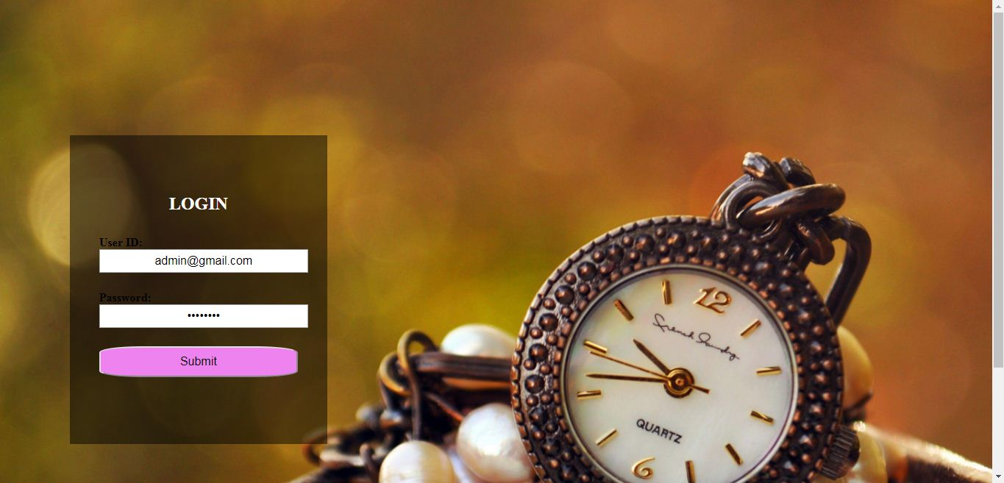

**Admin :**



**Admin Product View :**

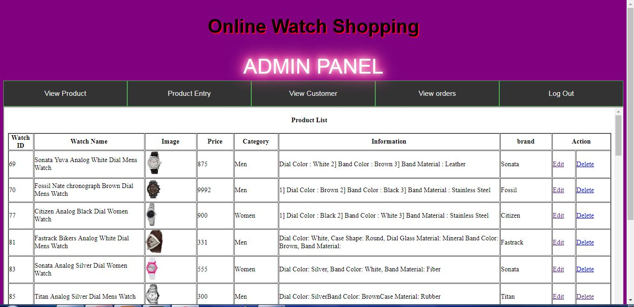

**Admin Product Entry :**

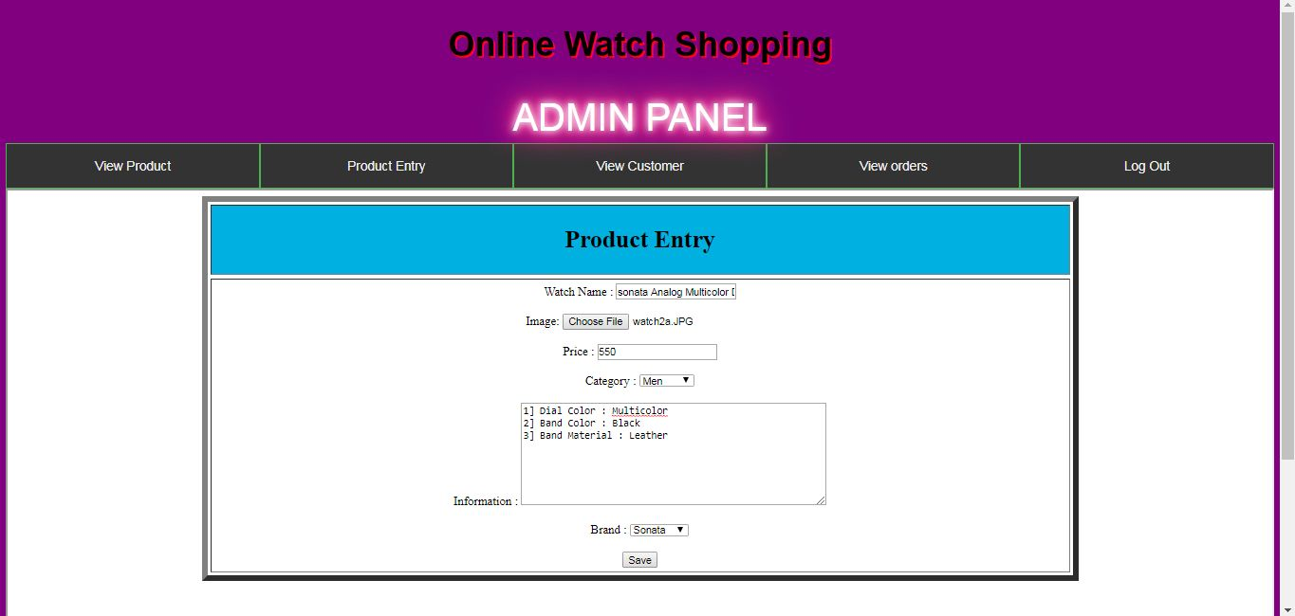

**Admin view Orders :**



**Home Page :**

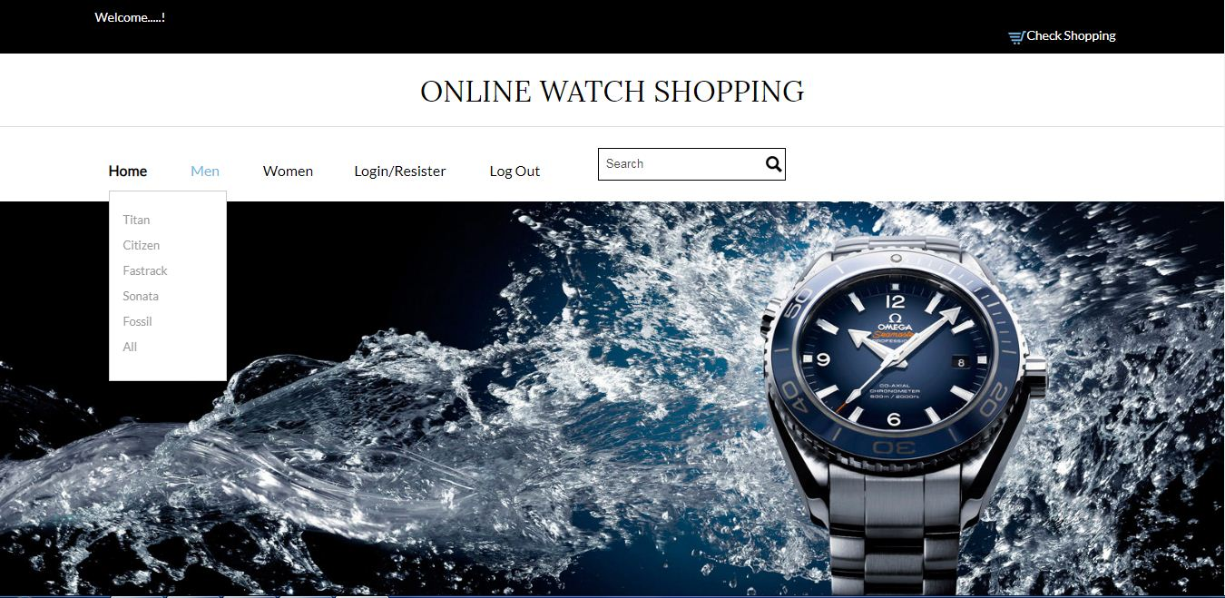

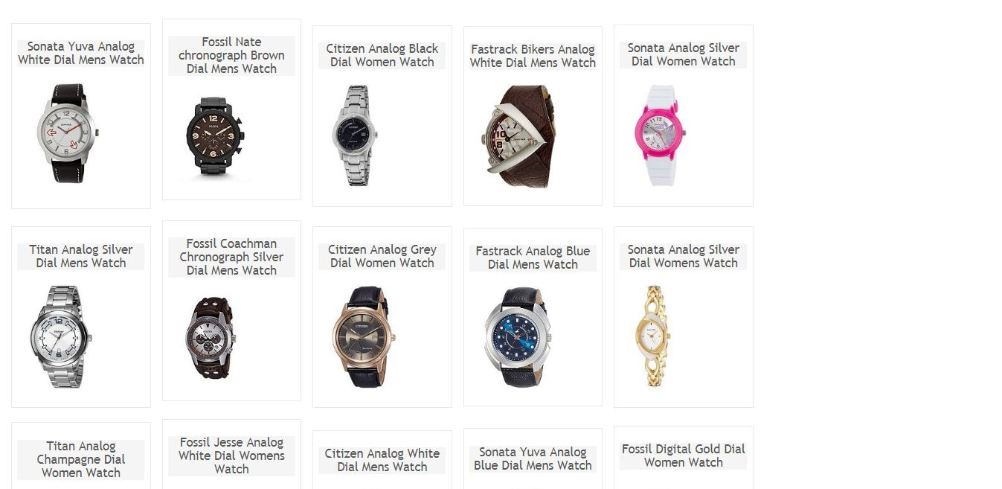

**Watch Details - Home Page:**

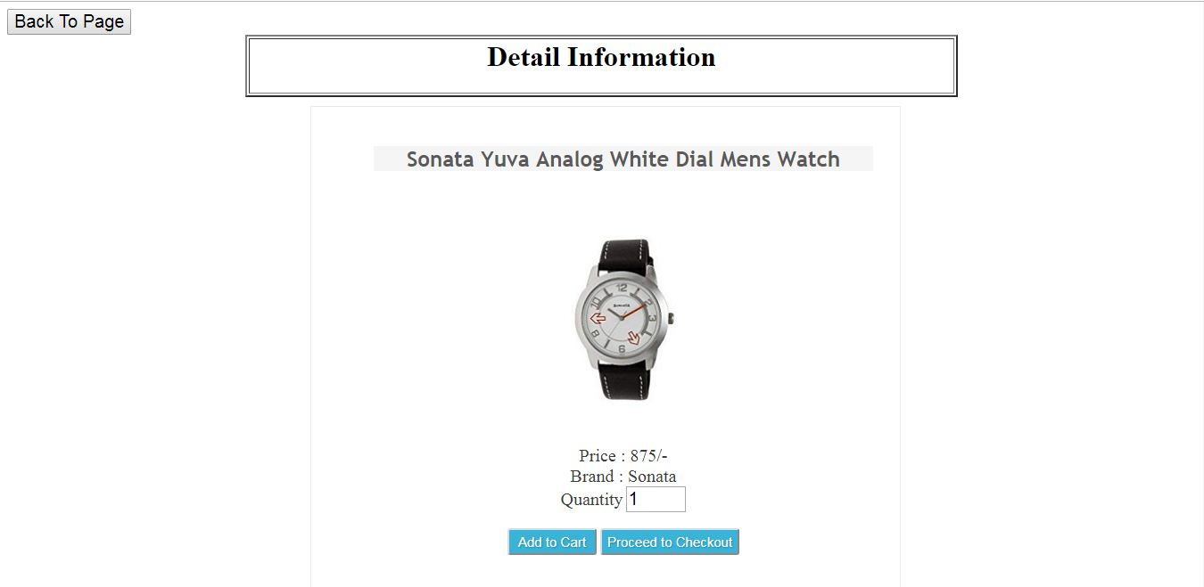

**Sub-Menu Page :**

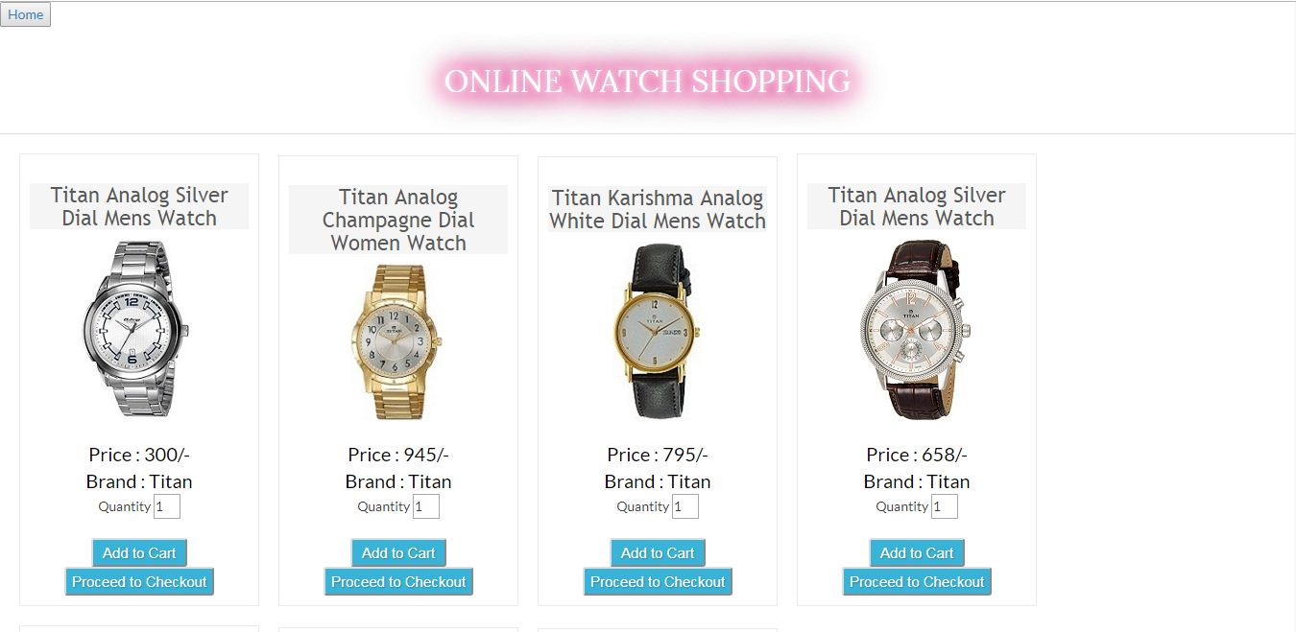

**Watch Information - Menu Page:**

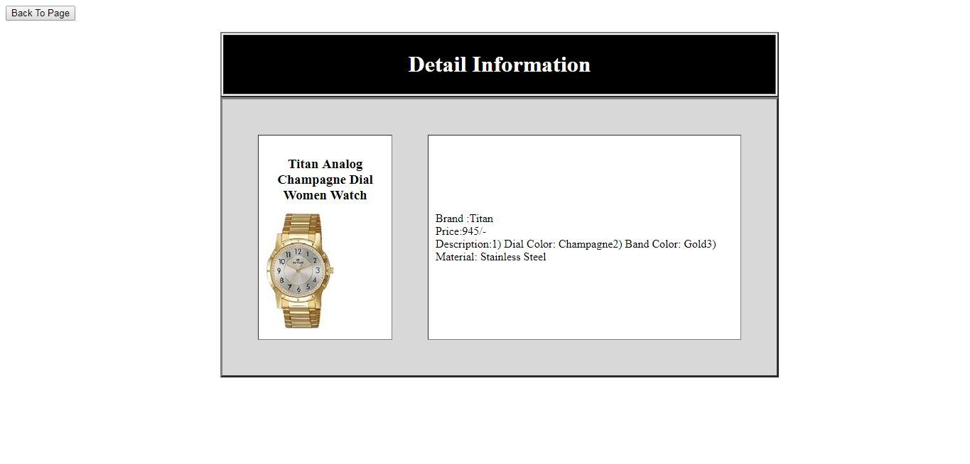

**Order(Cart) Page :**

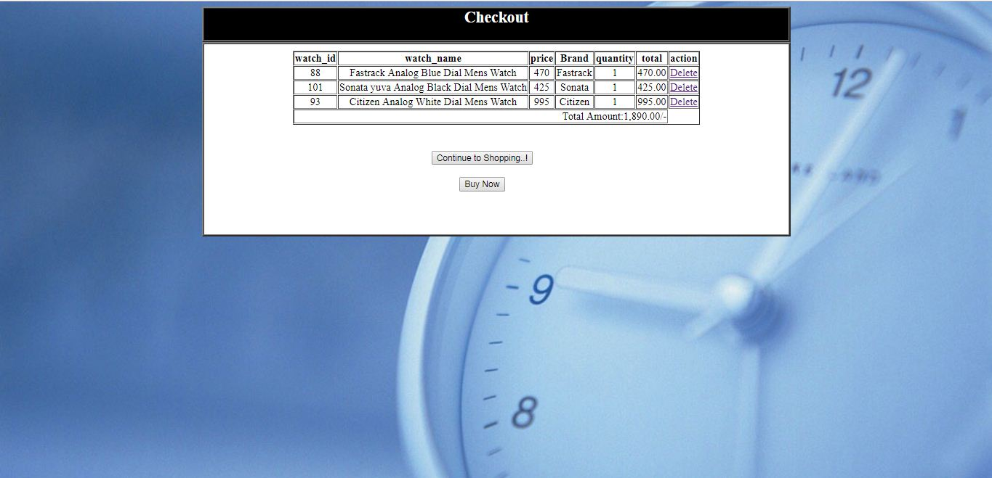

**Bill :**

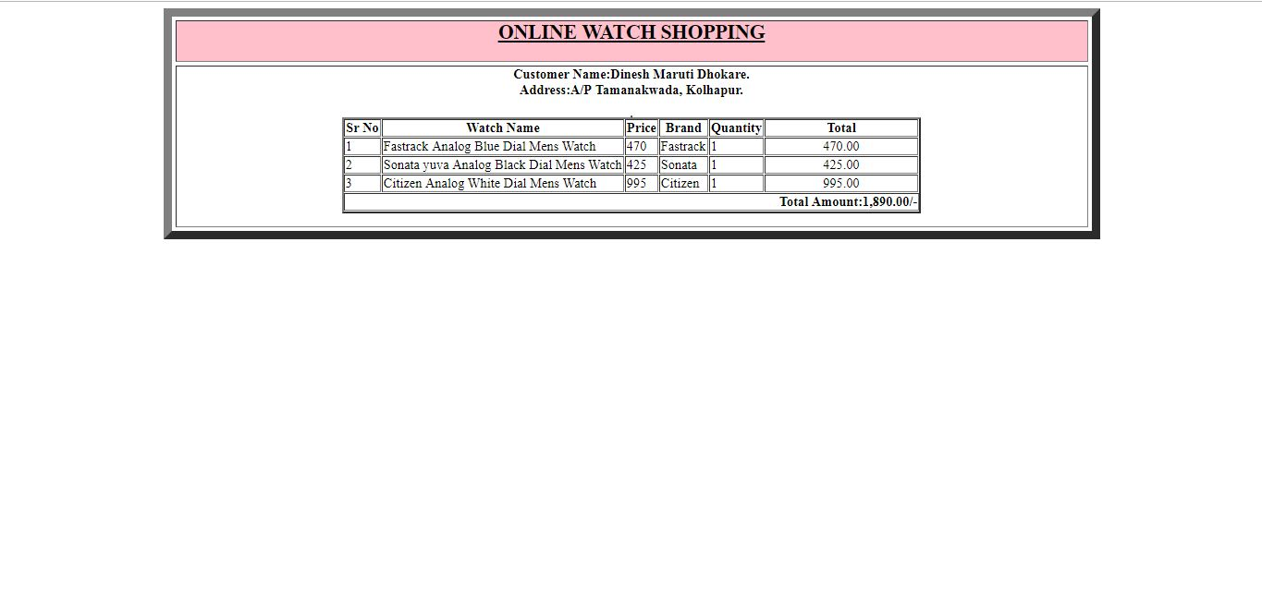

**6] Conclusion**

In this project, the user is provided with an e-commerce web site that can be used to buy products online.

A good shopping cart design must be accompanied with user-friendly shopping cart application logic. It should be convenient for the customer to view the contents of their cart and to be able to remove or add items to their cart. The online Watch shop application described in this project provides a number of features that are designed to make the customer more comfortable.

* User is provided the option of monitoring the records he entered earlier. He can see the desired records with the variety of options provided by him.
* From every part of the project the user is provided with the links through framing so that he can go from one option of the project to other as per the requirement. This is bound to be simple and very friendly as per the user is concerned. That is, we can sat that the project is user friendly which is one of the primary concerns of any good project.
* Data storage and retrieval will become faster and easier to maintain because data is stored in a systematic manner and in a single database.
* Decision making process would be greatly enhanced because of faster processing of information since data collection from information available on computer takes much less time then manual system.
* Allocating of sample results becomes much faster because at a time the user can see the records of last years.
* Through these features it will increase the efficiency, accuracy and transparency.

**7] Bibliography**

* WWW.google.com
* WWW.w3school.com
* WWW.youtube.com